Identifying system type [root@172 packer]# uname -a Linux 172.31.30.129 4.18.0-80.4.2.el8_0.x86_64 #1 SMP Fri Jun 14 13:20:24 UTC 2019 x86_64 x86_64 x86_64 GNU/Linux

Installing curl, wget and zip functionality yum install curl yum install zip unzip -y yum install -y wget

AWS CLI installation curl "https://awscli.amazonaws.com/awscli-exe-linux-x86_64.zip" -o "awscliv2.zip" unzip awscliv2.zip sudo ./aws/install

Installing packer https://packer.io/downloads.html -> select linux-> 64 bit(download correct package), and unzip it

Verifying packer version packer --version -> 1.5.3

Usage: packer [--version] [--help] <command> [<args>]

Available commands are: build build image(s) from template Console creates a console for testing variable interpolation fix fixes templates from old versions of packer inspect see components of a template validate check that a template is valid version Prints the Packer version

packer build -debug ./json file (if we specify -debug option then it stop after every logical line)

Writing json file for packer- Syntax is give under packer documentation, go ahead and use them. We need below details handy when we are writing packer file.

AWS region(ge it from console url) [https://us-east-2.console.aws.amazon.com/console/home?nc2=h_ct&region=us-east-2&src=header-signin#](https://us-east-2.console.aws.amazon.com/console/home?nc2=h_ct&region=us-east-2&src=header-signin) alternative is you can google about it.

Access key and secrete key – When you create IAM user then you get Access key and secrete key details.

Source image – Instance type.

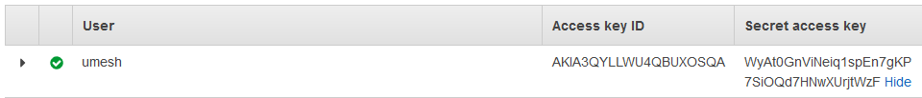

Packer inspect ./jsonfile -> it will classify Jason file into variable, builder and provisioner section.

-var “key” “value” – if you don’t want to specify access key and secrete key then we can this.

What is image?- it’s a copy of running instance, that we use to create environment.

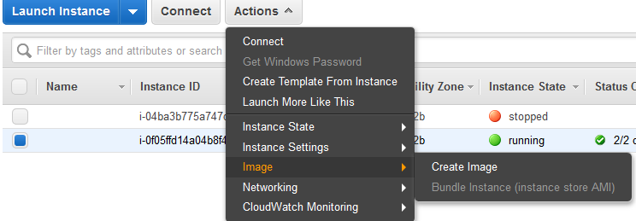

If We don’t want to pass hardcode details like access key and secrete key then we can use concept the variable.